KUBERNETES[TASK-1]

1) Setup Minikube in your local machine.

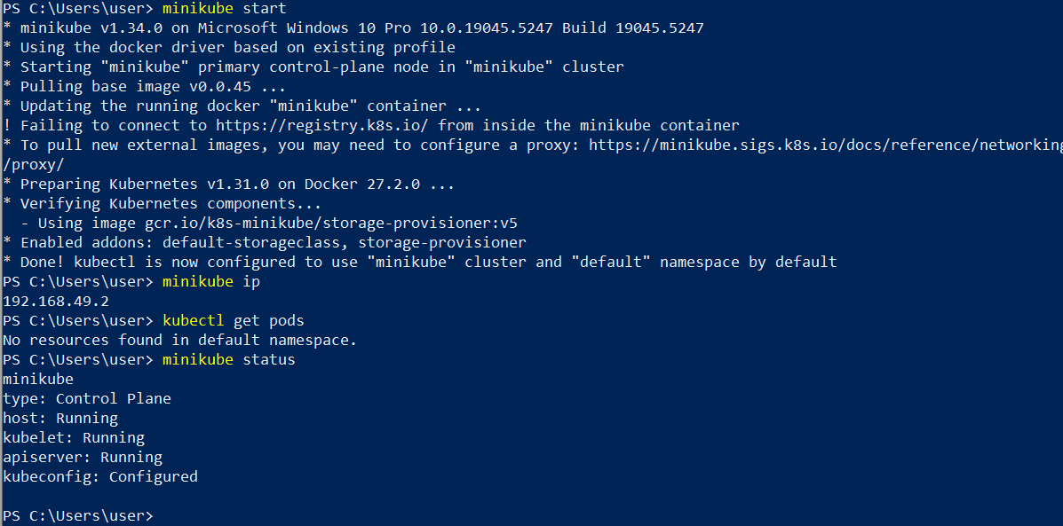

**2) Setup k8s master and two worker nodes on ubuntu.**

1) launch 3 instances of type t2.medium and linux2 AMI.

2) Disable swap memory from instances.(Because k8s wants the cpu to utilized 100%)

free - h to check the swap memeory allocated

swapoff -a to off the swap memory

To not enable this after restart then comment this in fstab file.

3) Install docker based on Operating system in 3 instances.

https://docs.docker.com/engine/install/

4) To setup k8s cluster we have different tools like kops and kubeadm.

https://kubernetes.io/docs/setup/production-environment/tools/kubeadm/install-kubeadm/

5) Now we need to setup networking and configure master and worker nodes.

https://kubernetes.io/docs/setup/production-environment/tools/kubeadm/create-cluster-kubeadm/

6) TO configure master we need to initialize with CIDR

kubeadm init --pod-network-cidr=10.244.0.0/16

7) To start using your cluster, you need to run the following as a regular user:

mkdir -p $HOME/.kube

sudo cp -i /etc/kubernetes/admin.conf $HOME/.kube/config

sudo chown $(id -u):$(id -g) $HOME/.kube/config

8) If we execute kubectl get nodes we can see the status as notready because we haven't installed flannel

9) Install Flannel and check the status of nodes

kubectl apply -f https://github.com/flannel-io/flannel/releases/latest/download/kube-flannel.yml

10) Now copy the token and execute on worker machines.

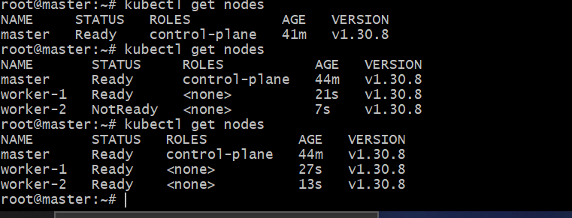

3) Run one nginx pod.

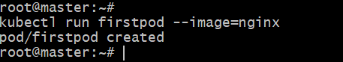

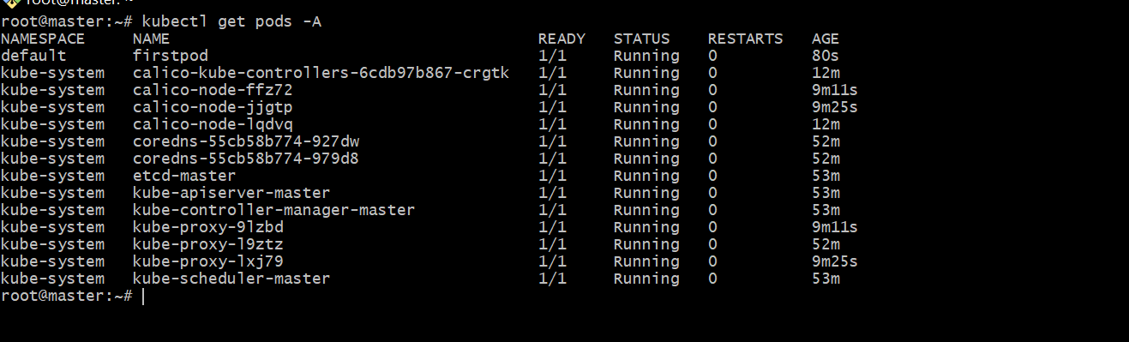

4) Mugup Master and slave components on k8s.

Master:

Kube api server

Etcd

Controller

Scheduler

Worker Node:

Docker container runtime

Kubelet agent

Kubeproxy